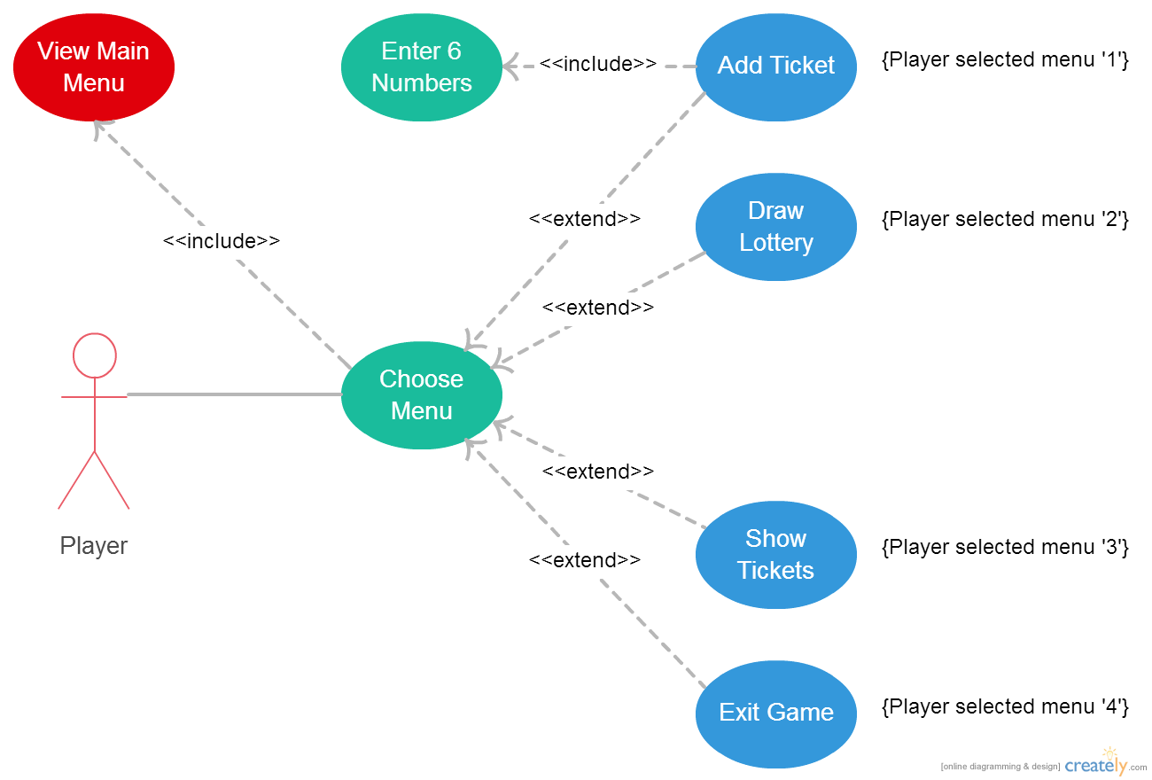

|  |  |  |
| --- | --- | --- |
| Use – Case | Add Ticket | |
| Primary Actor | Player | |
| Precondition | Player has selected option “1” from main menu. | |
| Post - Condition | The game records the ticket of 6 numbers from 1 to 49. | |
| Flow of Events | **Actor’s Input** | **System’s Response** |
|  | Chose numbers for a ticket. |  |
|  |  | Stores the ticket to a program. |
| Alternative Flow | Condition: Numbers didn’t create a valid ticket. | |
|  | **Actor’s Input** | **System’s Response** |
|  |  | Alert the player about invalid numbers on the ticket. |
|  |  | Return to the main menu. |

|  |  |  |
| --- | --- | --- |
| Use – Case | Draw Number | |
| Primary Actor | Player | |
| Precondition | Player has selected option “2” from main menu. | |
| Post - Condition | The game records 6 random numbers from 1 to 49. | |
| Flow of Events | **Actor’s Input** | **System’s Response** |
|  |  | Stores all six random numbers to the program. |
|  |  | Display numbers to the screen. |

|  |  |  |
| --- | --- | --- |
| Use – Case | Show Ticket | |
| Primary Actor | Player | |
| Precondition | Player has selected option “3” from main menu with lottery numbers drawn. | |
| Post - Condition | The game displays the lottery number and lists all tickets including the number of hits. | |
| Flow of Events | **Actor’s Input** | **System’s Response** |
|  |  | Displays the lottery, all tickets, and total hits for each ticket. |
| Alternative Flow | Condition: Lottery not drawn | |
|  | **Actor’s Input** | **System’s Response** |
|  |  | Draw all 6 lottery numbers and store them. |
|  |  | Displays the lottery, all tickets, and total hits for each ticket. |
|  | Condition: No tickets | |
|  | **Actor’s Input** | **System’s Response** |
|  |  | Tells the player to enter a ticket. |
|  |  | Return to the main menu. |

|  |  |  |
| --- | --- | --- |
| Use – Case | Exit Game | |
| Primary Actor | Player | |
| Precondition | Player has selected option “4” from main menu. | |
| Post - Condition | The program terminates. | |
| Flow of Events | **Actor’s Input** | **System’s Response** |
|  |  | Display a thank you message. |

|  |  |  |
| --- | --- | --- |
| Use – Case | Enter 6 Numbers | |
| Primary Actor | Player | |
| Precondition | Player enters a ticket | |
| Post - Condition | The game records the all numbers received to the ticket. | |
| Flow of Events | **Actor’s Input** | **System’s Response** |
|  | 6 integers from 1 to 49 |  |
|  |  | Stores the number to a ticket. |
| Alternative Flow | Condition: Numbers out of range of [1, 49], duplicated numbers, input not a number, or total numbers received is not exactly 6. | |
|  | **Actor’s Input** | **System’s Response** |
|  |  | Generates a message according to an error in player’s input. |

|  |  |  |
| --- | --- | --- |
| Use – Case | Choose Menu | |
| Primary Actor | Player | |
| Precondition | The game displays a main menu | |
| Post - Condition | The game calls an operation according to the player’s option chosen. | |
| Flow of Events | **Actor’s Input** | **System’s Response** |
|  | A number 1, 2, 3, or 0. |  |
|  |  | Call a function according to the choice chosen |
| Alternative Flow | Condition: Other input than 0, 1, 2, or 3 received. | |
|  | **Actor’s Input** | **System’s Response** |
|  |  | Alert the player about an invalid choice |
|  |  | Display the main menu. |

|  |  |  |
| --- | --- | --- |
| Use – Case | View Main Menu | |
| Primary Actor | Game | |
| Precondition | Player has started a game, or other game operations have finished. | |
| Post - Condition | The program displays a main menu. | |
| Flow of Events | **Actor’s Input** | **System’s Response** |
|  |  | Display a menu, with a list of all available operations. |